**Introduction**

CTIS or Covid Testing Information System is a product we developed in this project, the product will be in the form of website, this website will help user to keep track of data they needed based on the user position, such as test result data, user data, test kit data and test center data. This system will help user to get information regarding covid easier.

In this report will be included the design documentation of the system, such as: use case diagram, class diagram, ERD, Sitemap, wireframe and data dictionary. This design documentation provides all the necessary information to provide description of the details for the software and system built as well as the high-level explanation of how this system will function, components and functions that are being developed.

**Usecase Diagram**

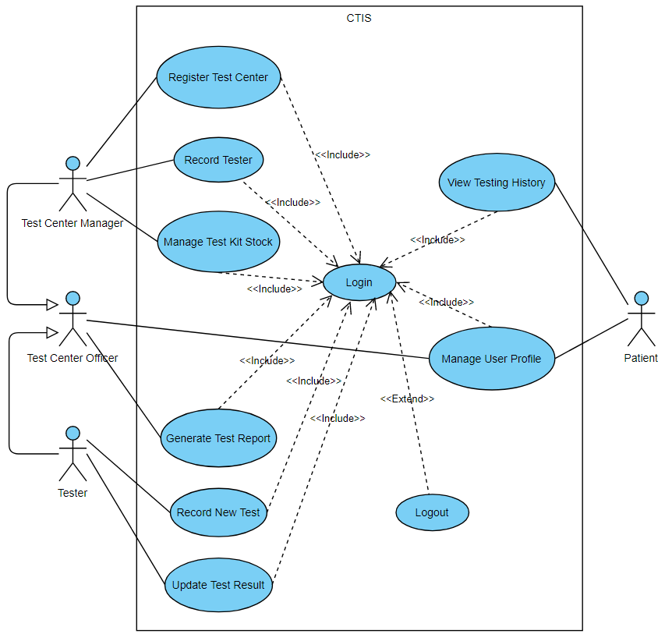

**Design Specification**

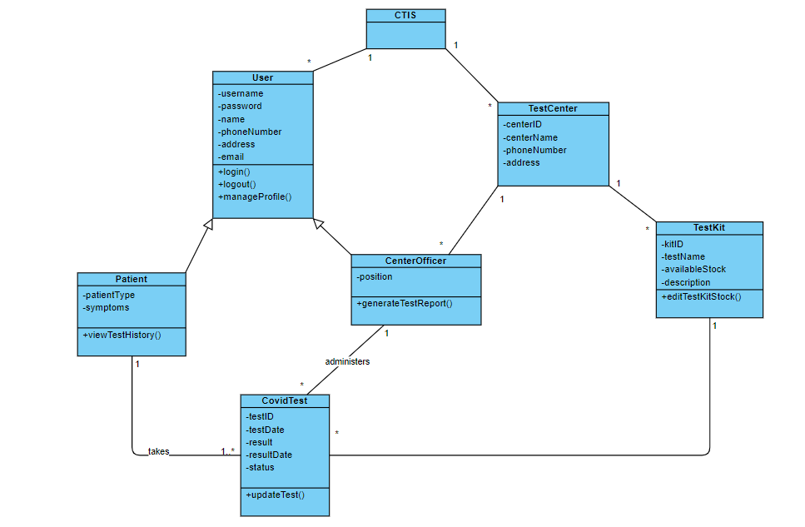**Class Diagram**

Note:

1. Added new attribute (description) for TestKit and (email) for User.

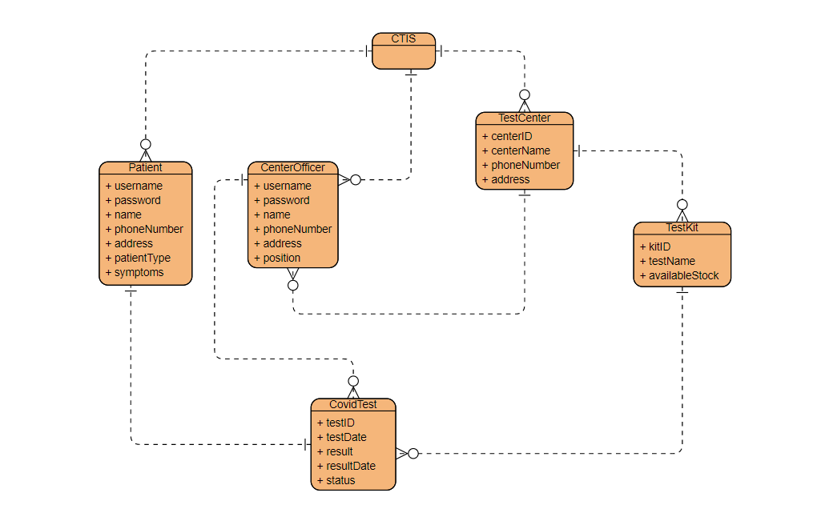**ERD (Conceptual View of Database)**

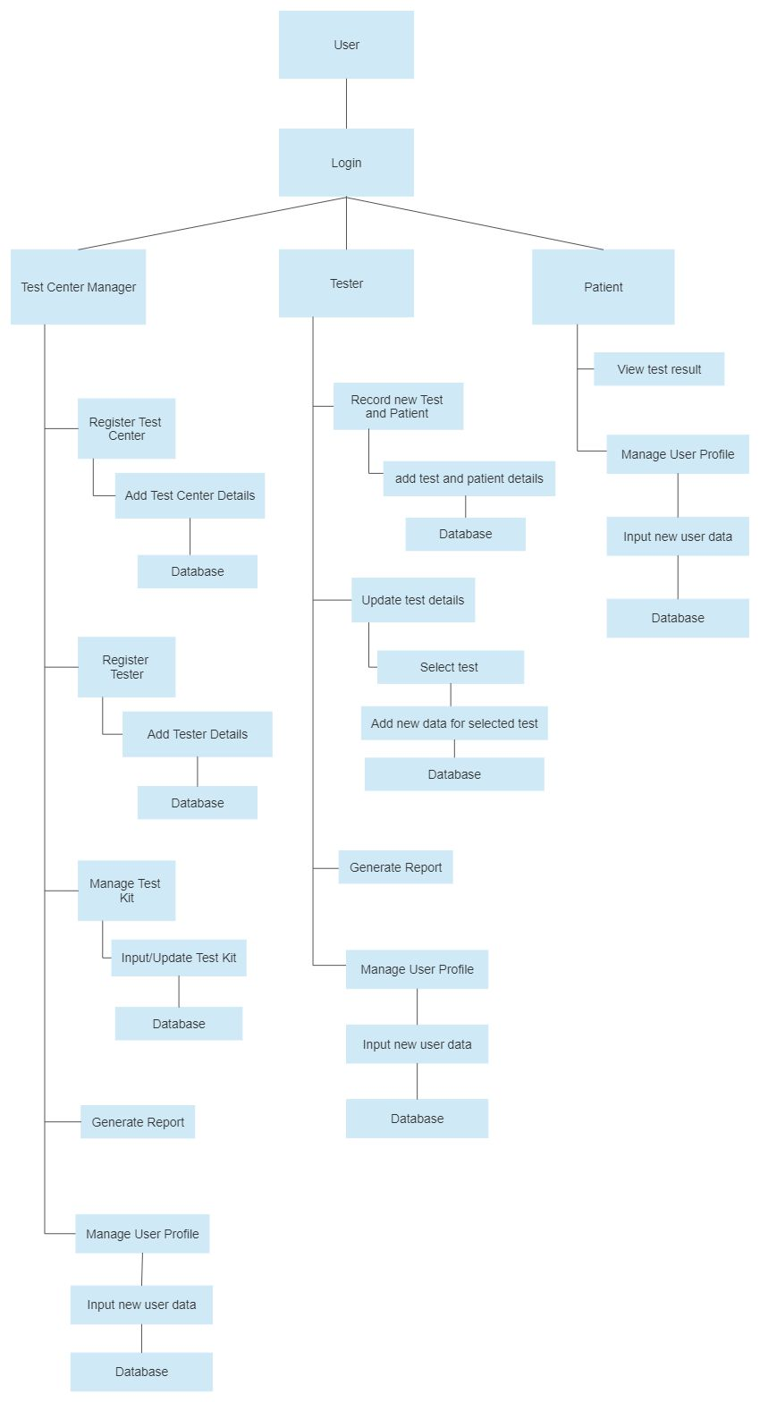**Sitemap**

**Generic User Experience/Wireframe**

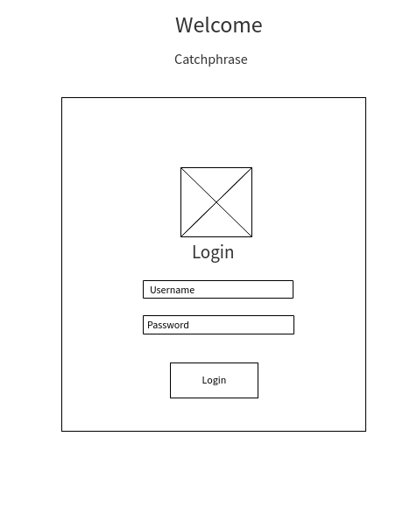**Login**

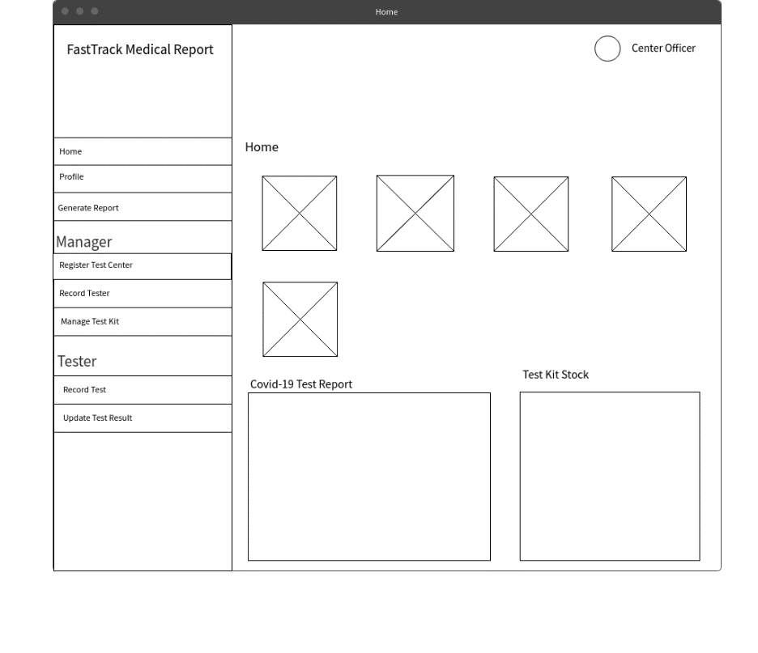**Home Officer**

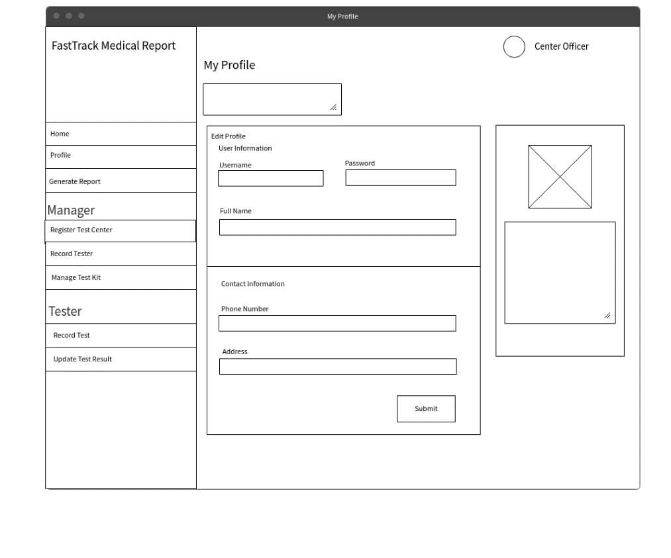**Manage Profile**

**Generate Report**

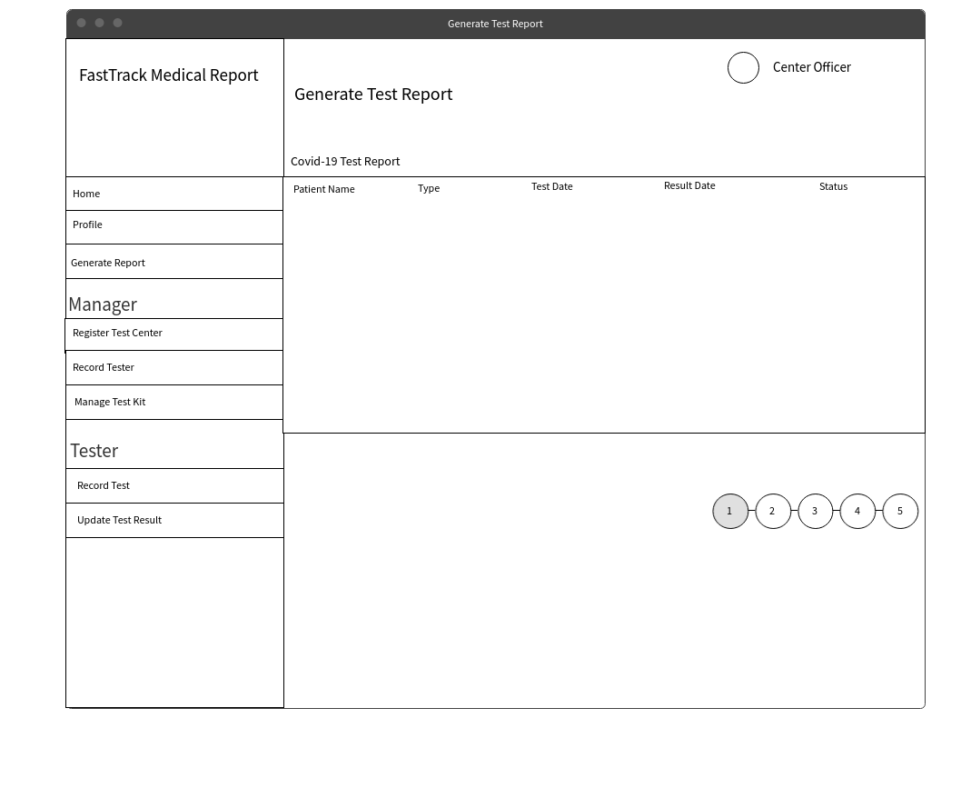

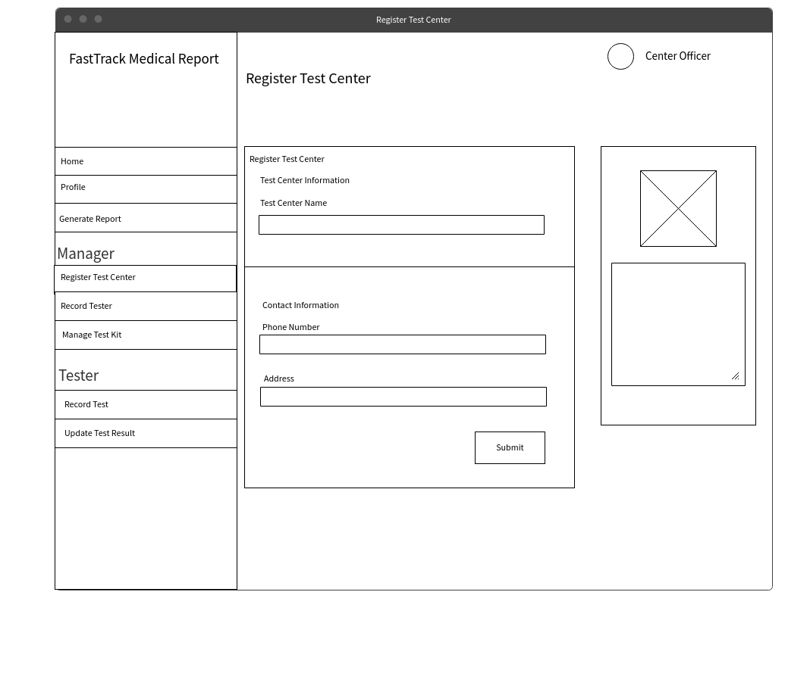**Register Test Center**

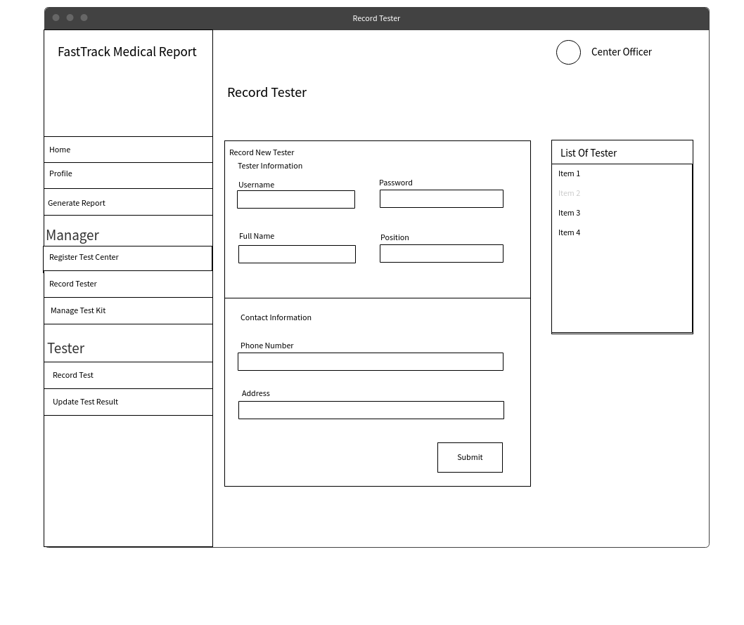**Record Tester**

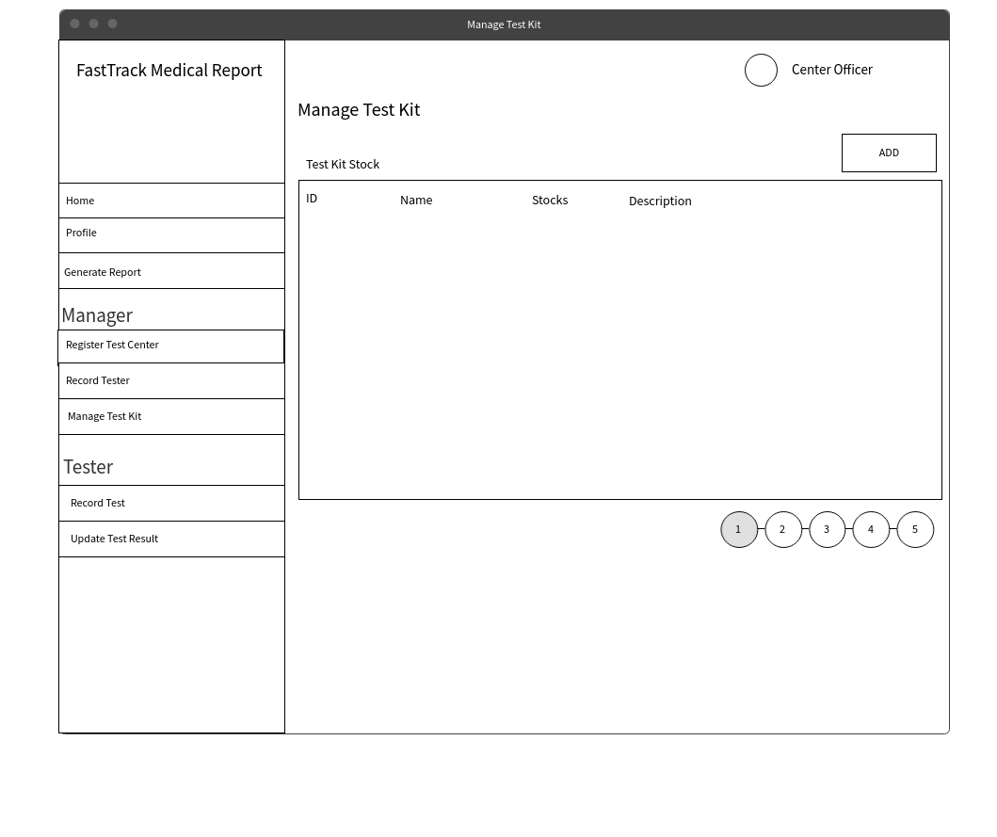**Manage Test Kit**

**Add Test Kit Stock**

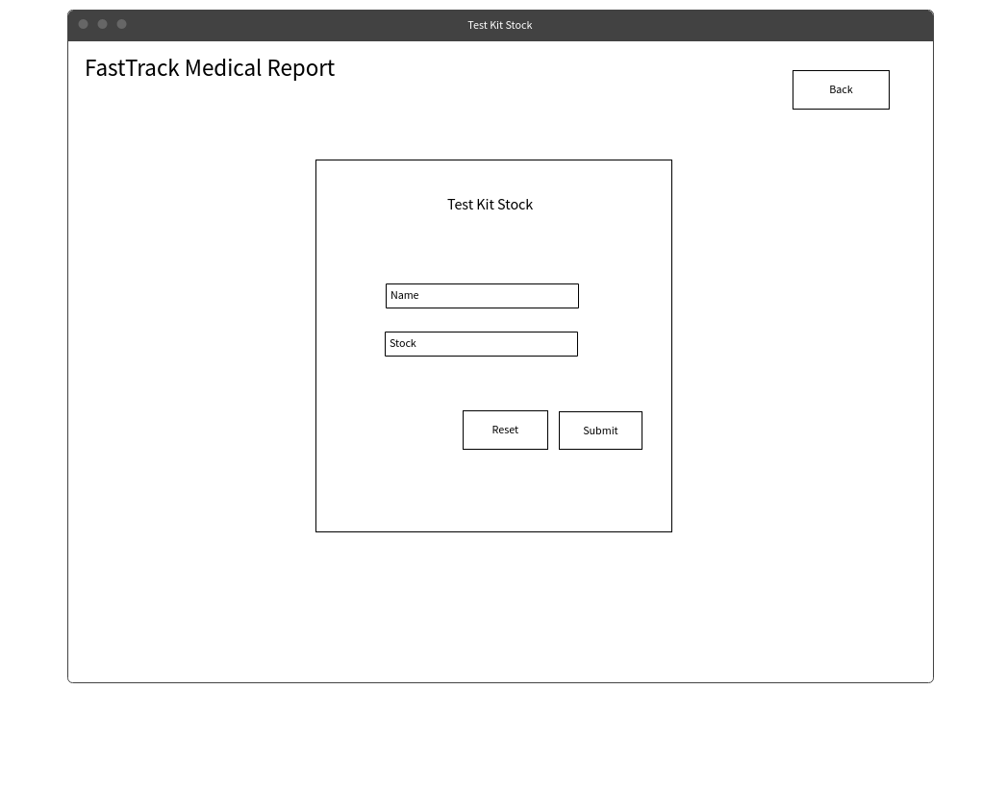

**Record Test**

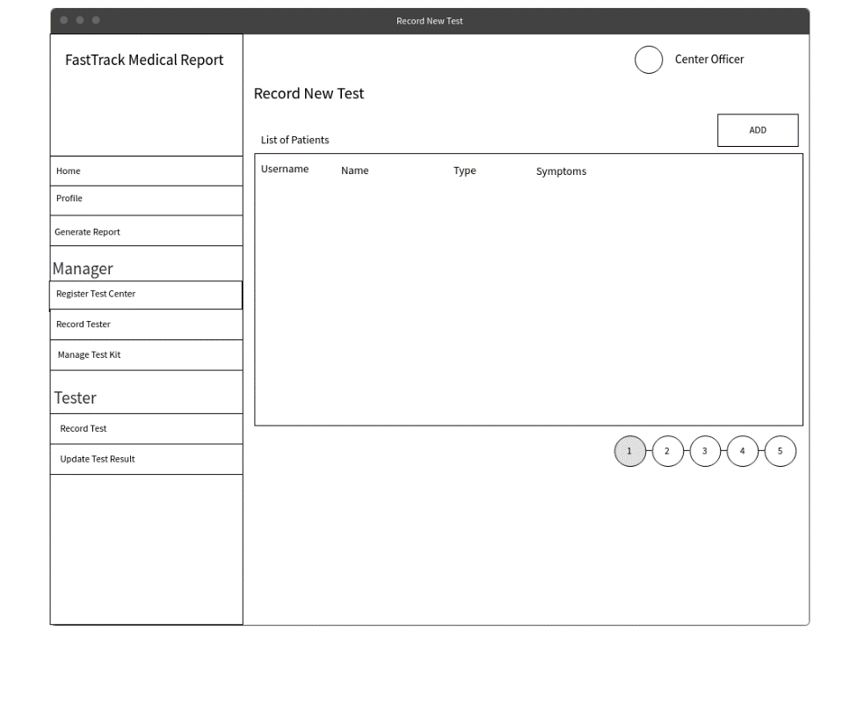 **Add New Patient**

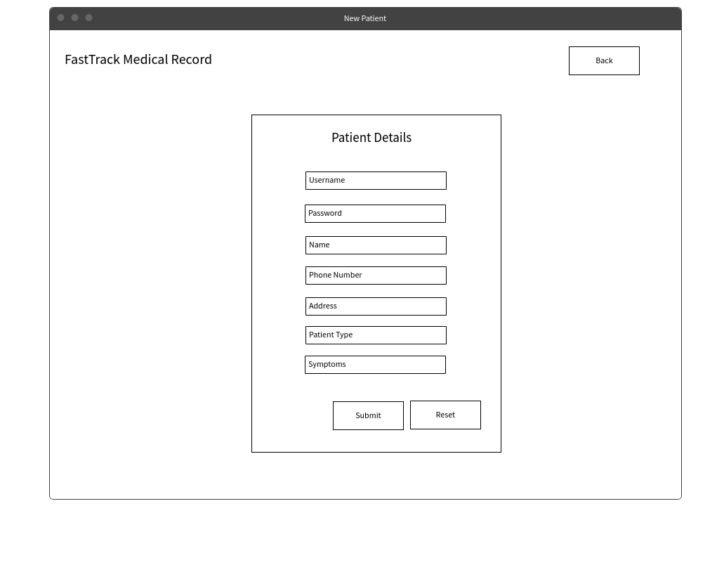

**Update Test Result**

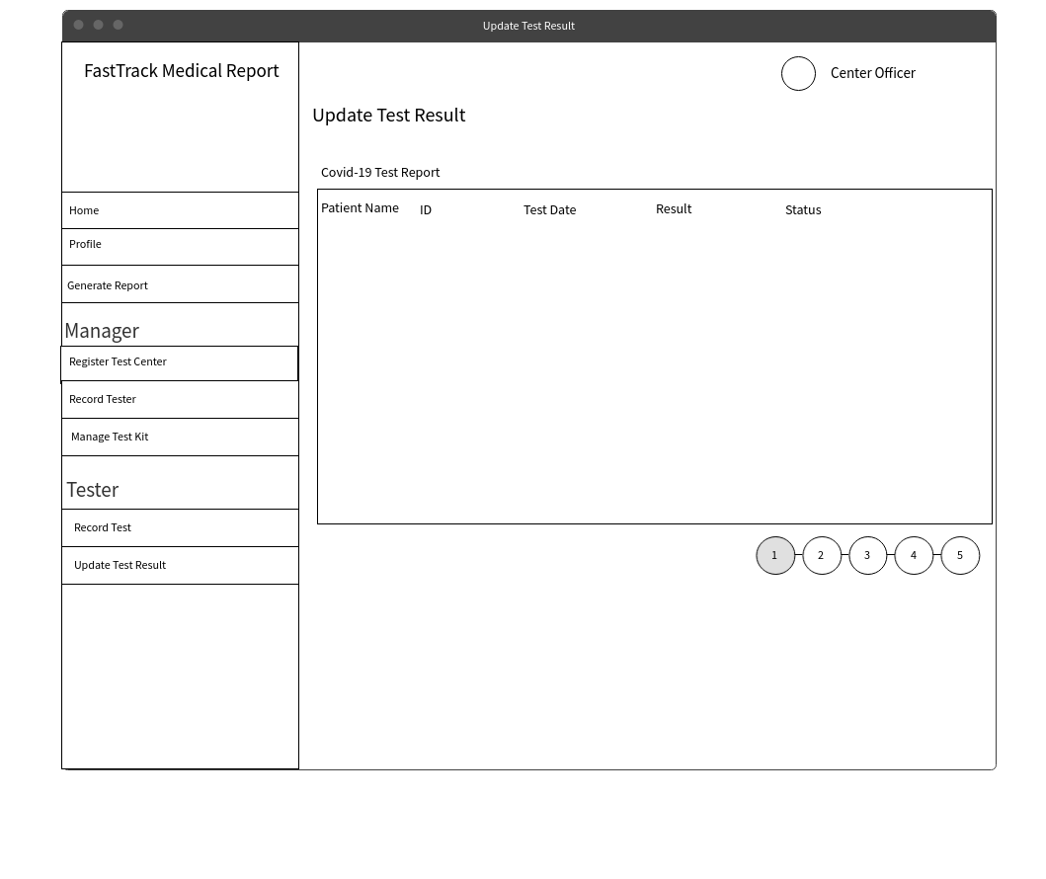

**Patient Home**

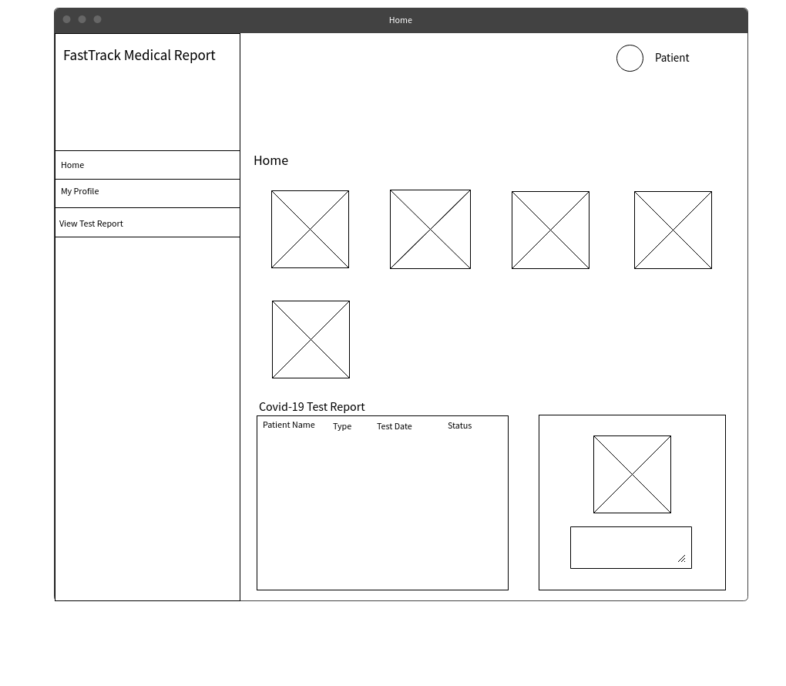

**View Test Report**

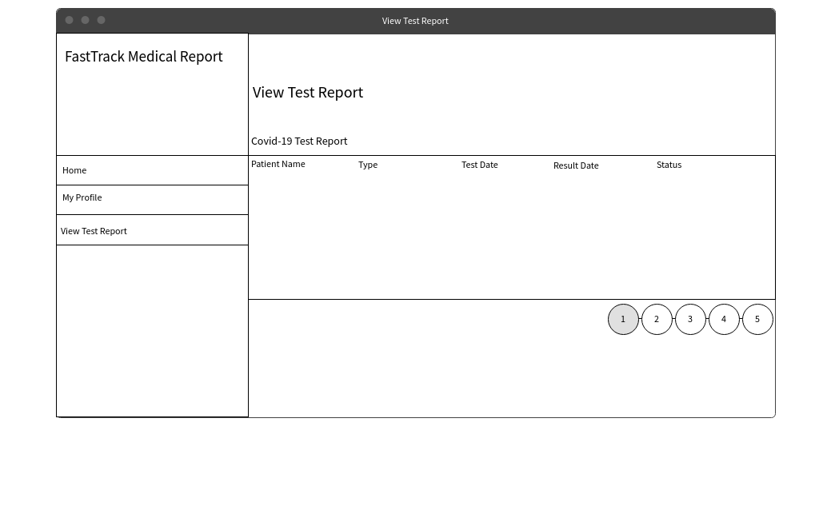

**System Sequence Diagram**

1. **Login**

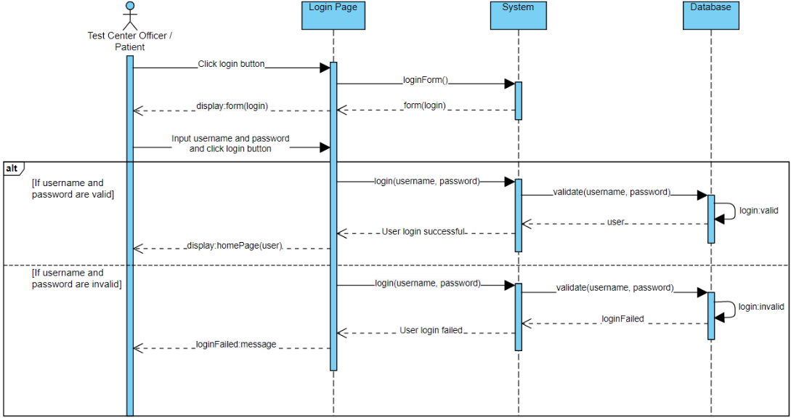

|  |  |
| --- | --- |
| **Cross Reference** | **Login** |
| **Operation** | Login with username and password |
| **Responsible** | To allow the test center officer or patient to access the CTIS |
| **Pre-conditions** | Username and password should match |
| **Post-conditions** | **If** the test center officer or patient enter the matched username and password  **Then**, system will display the home page  **Else**, system will indicate error and require to re-enter username and password |

1. **Logout**

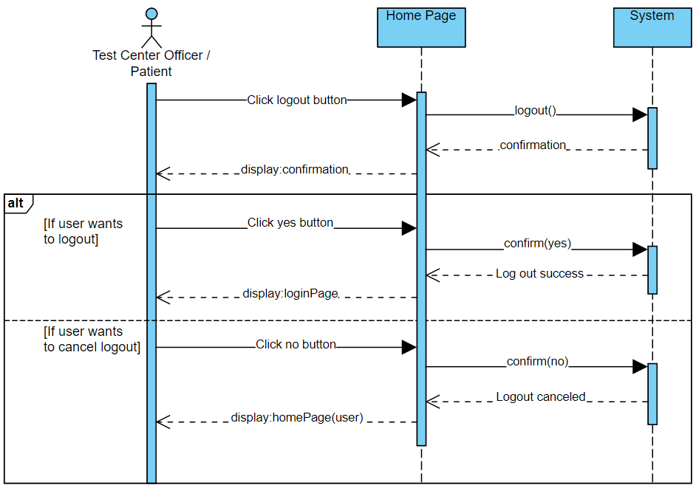

|  |  |
| --- | --- |
| **Cross Reference** | **Logout** |
| **Operation** | Test center officer or patient logout from the CTIS |
| **Responsible** | To allow the test center officer or patient to logout of the CTIS |
| **Pre-conditions** | The test center officer or patient has to finish using the features they used before |
| **Post-conditions** | **If** the test center officer or patient log out of the CTIS and click yes in the confirmation message  **Then**, the test center officer or patient account will be logging out of the CTIS and display the login page  **Else**, logout canceled by the test center officer or patient |

1. **Manage User Profile**

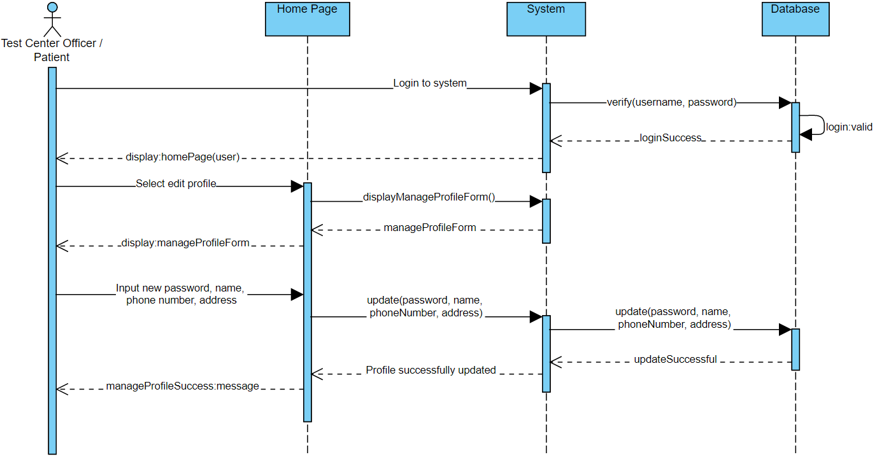

|  |  |
| --- | --- |
| **Cross Reference** | **Manage User Profile** |
| **Operation** | Login with username and password |
| **Responsible** | To get access to manage the test center officer or patient profile |
| **Pre-conditions** | Username and password should match |
| **Post-conditions** | The test center officer or patient enter the matched username and password. Then, system will display the home page. |
| **Cross Reference** | **Manage User Profile** |
| **Operation** | Manage test center officer or patient profile |
| **Responsible** | To allow the test center officer or patient to manage their profile |
| **Pre-conditions** | Test center officer or patient account should be registered |
| **Post-conditions** | * The test center officer or patient profile updated * Display successful notification |

1. **Register Test Center**

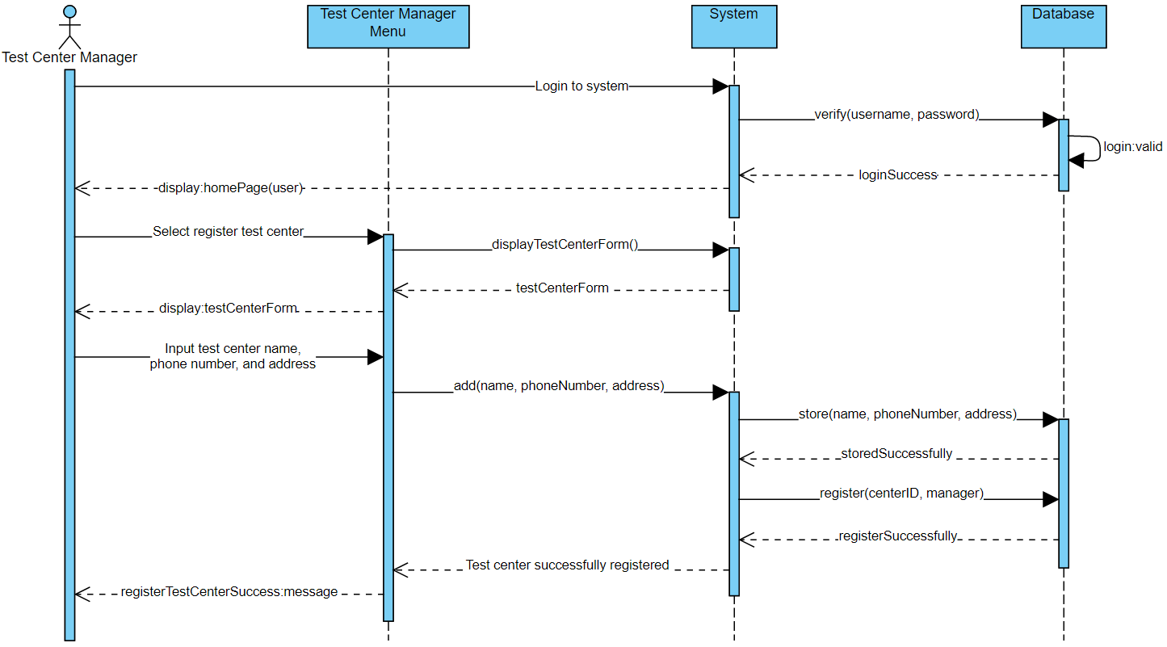

|  |  |
| --- | --- |
| **Cross Reference** | **Register Test Center** |
| **Operation** | Login with username and password |
| **Responsible** | To get access for the test center manager to register test center |
| **Pre-conditions** | Username and password should match |
| **Post-conditions** | The test center manager enters the matched username and password. Then, system will display the home page. |
| **Cross Reference** | **Register Test Centre** |
| **Operation** | Test center manager register test center |
| **Responsible** | To allow the test center manager to register the test center |
| **Pre-conditions** | * Test center must be approved * Test center manager’s account must be set up as center officer * Test center data (name, phone number, and address) must be available |
| **Post-conditions** | * Test center is registered * The centerID is automatically generated * Display successful notification |

1. **Record Tester**

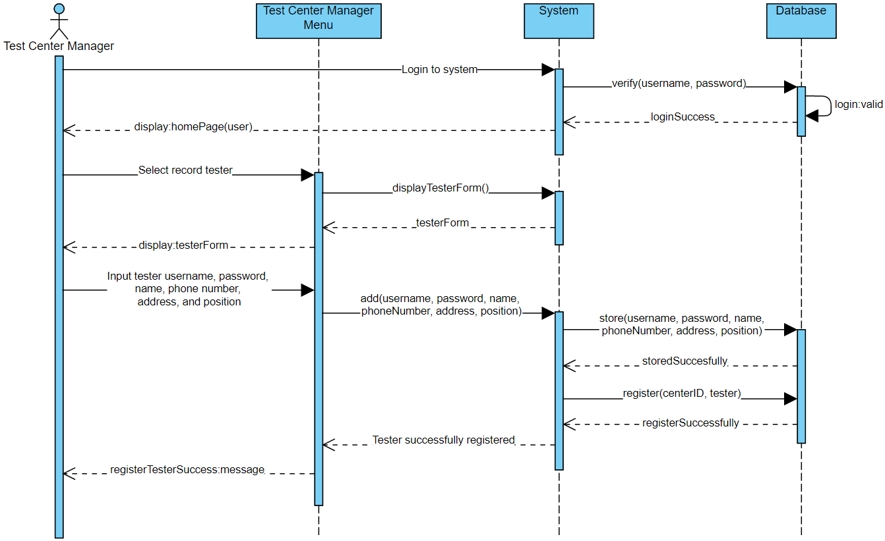

|  |  |
| --- | --- |
| **Cross Reference** | **Record Tester** |
| **Operation** | Login with username and password |
| **Responsible** | To get access for the test center manager to record new tester |
| **Pre-conditions** | Username and password should match |
| **Post-conditions** | The test center manager enters the matched username and password. Then, system will display the home page. |
| **Cross Reference** | **Record Tester** |
| **Operation** | Test center manager record new tester |
| **Responsible** | To allow the test center manager to record new tester |
| **Pre-conditions** | Tester data (username, password, name, phone number, address, and position) must be available |
| **Post-conditions** | * New tester will be recorded and registered to the test center * Display successful notification |

1. **Manage Test Kit**

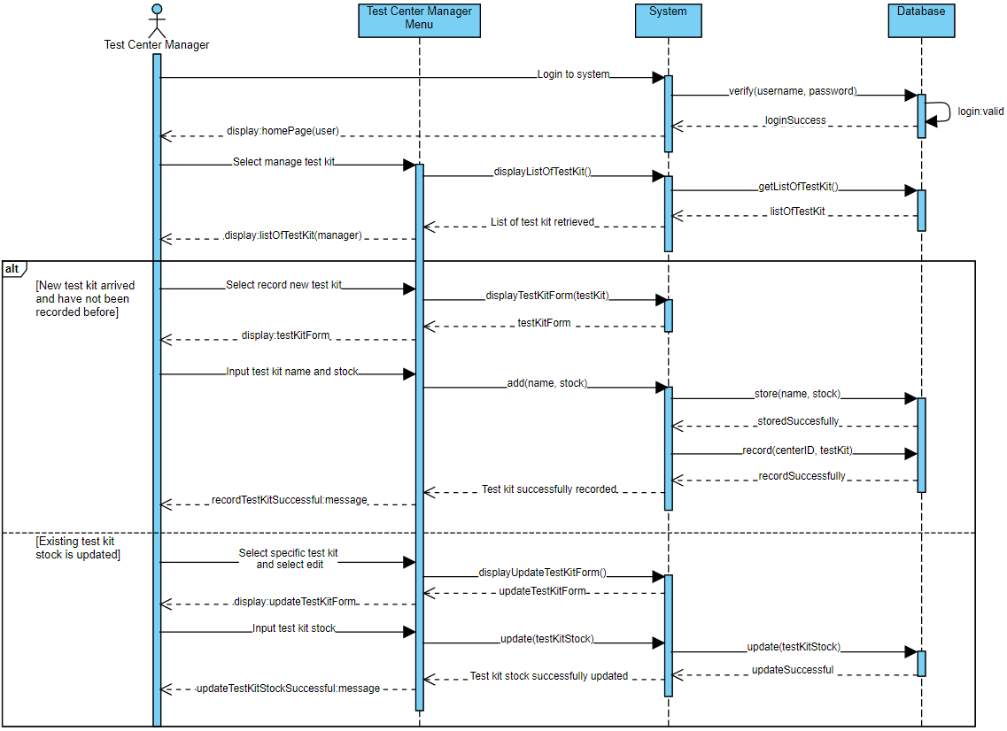

|  |  |
| --- | --- |
| **Cross Reference** | **Manage Test Kit Stock** |
| **Operation** | Login with username and password |
| **Responsible** | To get access for the test center manager to record test kit |
| **Pre-conditions** | Username and password should match |
| **Post-conditions** | The test center enters the matched username and password. Then, system will display the home page. |
| **Cross Reference** | **Manage Test Kit Stock** |
| **Operation** | Test Centre Manager manage test kit stock |
| **Responsible** | To allow the test center manager to manage the stock of test kit in the test center |
| **Pre-conditions** | New stock of test kit arrived |
| **Post-conditions** | **If** the test center manager receives new test kit  **Then**, new test kit will be recorded and display successful notification  **Else**, there is existing stock for test kit then its stock updated |

1. **Record New Test**

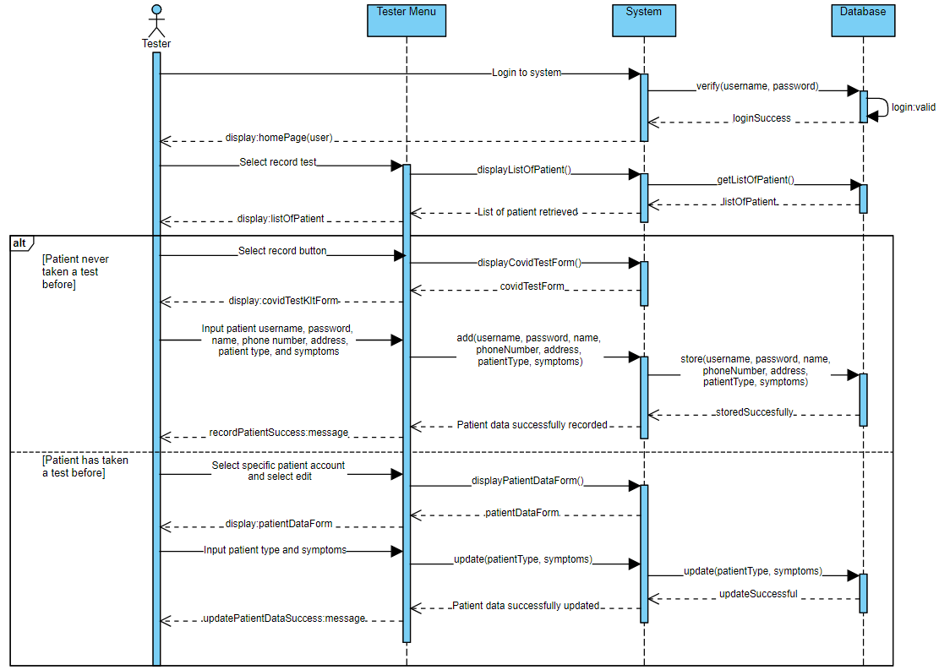

|  |  |
| --- | --- |
| **Cross Reference** | **Record New Test** |
| **Operation** | Login with username and password |
| **Responsible** | To get access for the tester to record new test |
| **Pre-conditions** | Username and password should match |
| **Post-conditions** | The tester enters the matched username and password. Then, system will display the home page. |
| **Cross Reference** | **Record New Test** |
| **Operation** | Tester record new test |
| **Responsible** | To allow the tester to record new test |
| **Pre-conditions** | Patient data (username, password, name, phone number, and address) must be available |
| **Post-conditions** | **If** patient never taken a test before  **Then**, patient data will be recorded by the tester and a new test automatically created after that system display successful notification  **Else**, the patient has a test record or taken a test before, the tester only updates the patient type and symptoms, new test automatically created |

1. **Update Test Result**

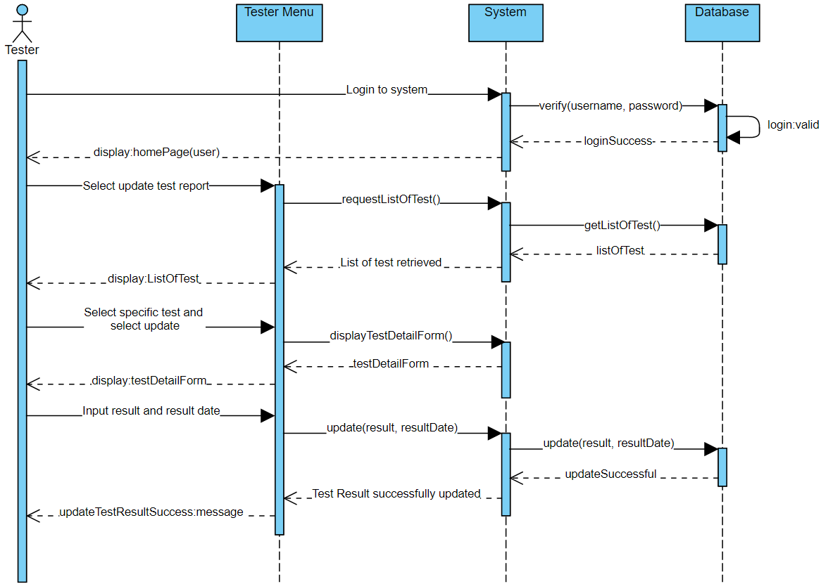

|  |  |
| --- | --- |
| **Cross Reference** | **Update Test Result** |
| **Operation** | Login with username and password |
| **Responsible** | To get access to edit test result of the patient |
| **Pre-conditions** | Username and password should match |
| **Post-conditions** | The tester enters the matched username and password. Then, system will display the home page. |
| **Cross Reference** | **Update Test Result** |
| **Operation** | To update the test details of the patient |
| **Responsible** | To allow the test center officer to manage the test result |
| **Pre-conditions** | * Patient should be registered * Test report should exist * Test result performed already out |
| **Post-conditions** | * Test report of patient data updated * Display successful notification |

1. 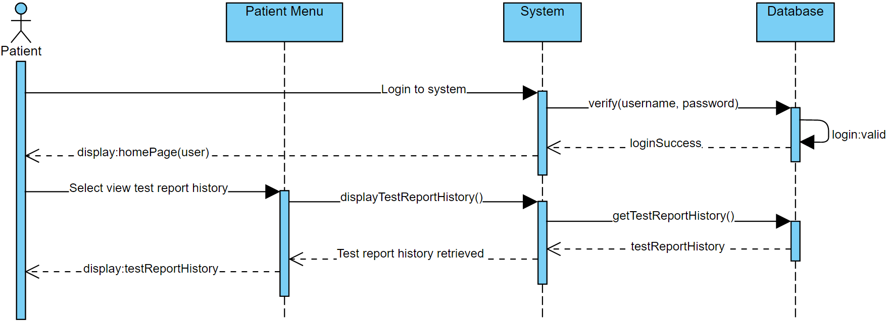**View Testing History**

|  |  |
| --- | --- |
| **Cross Reference** | **View Test History** |
| **Operation** | Login with username and password |
| **Responsible** | To get access to view test result of the test patient has taken before |
| **Pre-conditions** | Username and password should match |
| **Post-conditions** | The test center officer or patient enter the matched username and password. Then, system will display the home page. |
| **Cross Reference** | **View Test History** |
| **Operation** | To view the result of the test that has been taken |
| **Responsible** | To allow the patient to view the test result |
| **Pre-conditions** | Patient should have taken the covid-19 test before |
| **Post-conditions** | * System will display the patient profile * System will display the test history of patient |

1. **Generate Test Report**

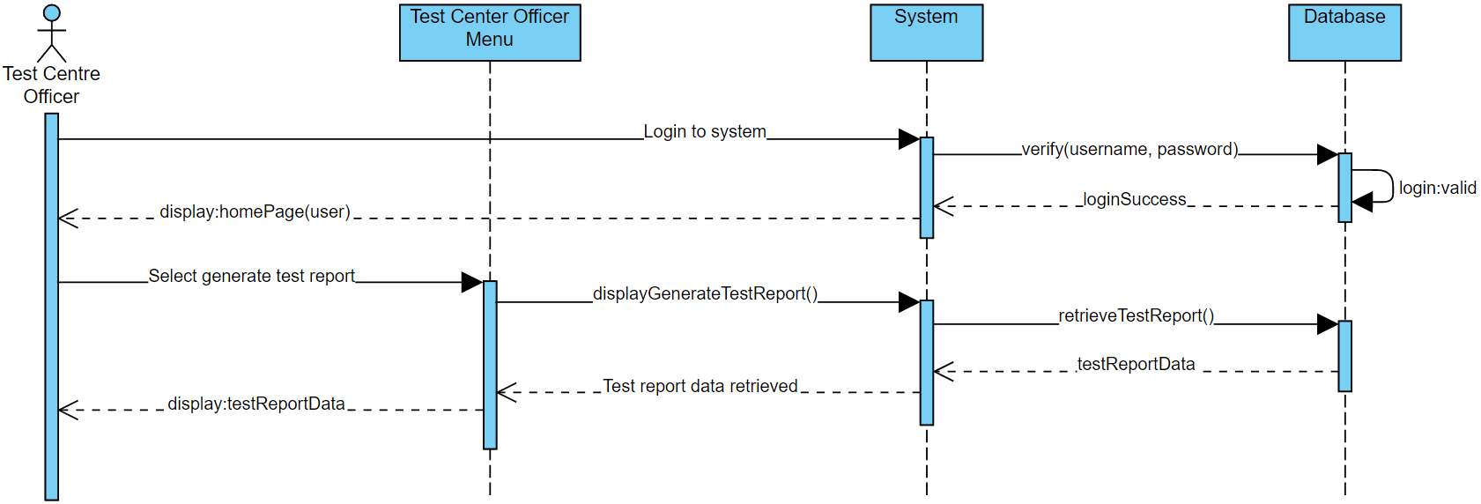

|  |  |
| --- | --- |
| **Cross Reference** | **Generate Test Report** |
| **Operation** | Login with username and password |
| **Responsible** | To get access to generate test report of the test that have been performed |
| **Pre-conditions** | Username and password should match |
| **Post-conditions** | The test center officer enters the matched username and password. Then, system will display the home page. |
| **Cross Reference** | **Generate Test Report** |
| **Operation** | To generate the result of the test that has been performed in the test center |
| **Responsible** | To allow the test center officer to generate the test result |
| **Pre-conditions** | Test center officer should be registered |
| **Post-conditions** | System will display the generated report of the test result |

**Database Design (Data Dictionary)**

**User**

|  |  |  |  |  |
| --- | --- | --- | --- | --- |
| **Field Name** | **Data Type** | **Field Size for Display** | **Description** | **Example** |
| Username | Varchar | 15 | Username of user | example123 |
| Password | Varchar | 15 | Password of user | example123 |
| Name | Varchar | 30 | Name of user | Salsabila Adriani |
| Phone Number | Varchar | 15 | Phone number of the user | 081293019892 |
| Address | Varchar | 100 | Address of user | Denpasar, Bali |
| Email | Varchar | 255 | Email of user | examplemail@gmail.com |

**Patient**

|  |  |  |  |  |
| --- | --- | --- | --- | --- |
| **Field Name** | **Data Type** | **Field Size for Display** | **Description** | **Example** |
| Patient Type | Varchar | 15 | Type of patient user | Returnee |
| Symptoms | Varchar | 50 | Symptoms of patient | Coughing, Fever, Headache |

**CenterOfficer**

|  |  |  |  |  |
| --- | --- | --- | --- | --- |
| **Field Name** | **Data Type** | **Field Size for Display** | **Description** | **Example** |
| Position | varchar | 18 | Type officer user | Center Manager |

**TestCenter**

|  |  |  |  |  |
| --- | --- | --- | --- | --- |
| **Field Name** | **Data Type** | **Field Size for Display** | **Description** | **Example** |
| Center ID | Integer | 11 | Unique ID of Test Center | 1 |
| Center Name | Varchar | 30 | Test Center Name | Puskesmas I Denpasar |
| Phone Number | Varchar | 15 | Phone number of the Test Center | 081342909876 |
| Address | Varchar | 100 | Address of Test Center | Denpasar, Bali |

**Test Kit**

|  |  |  |  |  |
| --- | --- | --- | --- | --- |
| **Field Name** | **Data Type** | **Field Size for Display** | **Description** | **Example** |
| Kit ID | Integer | 11 | Unique ID of Test Kit | 1 |
| Test Kit Name | Varchar | 30 | Test Kit Name | Sinofac |
| Available stock | Integer | 11 | Stock of Test Kit | 20 |
| Description | Varchar | 50 | Description of Test Kit | Sinofac is a test kit from china |

**CovidTest**

|  |  |  |  |  |
| --- | --- | --- | --- | --- |
| **Field Name** | **Data Type** | **Field Size for Display** | **Description** | **Example** |
| Test ID | Integer | 11 | Unique ID of Test | 1 |
| Test Date | Date | - | Date of test | 01/01/2021 |
| Result | Varchar | 100 | Result of the test | Positive |
| Result Date | int | 11 | Date of test result | 02/01/2021 |
| Status | varchar | 9 | Status of patient | Pending |

**Iteration 1**

**Identification of the use cases**

|  |  |
| --- | --- |
| **Use Case** | **Name** |
| Login | I Gede Made Armani Bagus Saputra |
| Logout | Ni Putu Dwi Candra Pertiwi |
| Manage User Profile | Ni Putu Dwi Candra Pertiwi |
| Register Test Center | I Gede Made Armani Bagus Saputra |
| Record Tester | I Gede Made Armani Bagus Saputra |
| Manage Test Kit | I Gede Made Armani Bagus Saputra |
| Record New Test | I Gede Made Armani Bagus Saputra |
| Update Test Result | Ni Putu Dwi Candra Pertiwi |
| View Test History | Ni Putu Dwi Candra Pertiwi |
| Generate Test Report | Ni Putu Dwi Candra Pertiwi |

**Test Objectives**

A test is an important step in developing a system information, a test is needed in order to make sure that the program fulfilled all the requirements that have been analyzed before and to find a solution to fix if there is an unusual behavior in the program. In developing a system, fault and failures are something that developer will stumbled upon, it can be caused by missing specification, impossible requirements, fault in system design, in program design and program code. Therefore, developers should be ready and able to handle the errors in the system. Design and Integration test will be performed in the development of this system to, first we will do Fault Identification to determine what faults that caused failure, then we will do Fault Correction/Removal by making changes and find a solution in the design or the coding of this program. For this system, we will focus on testing the design and functional requirements of the system such as:

1. User interface design is able to perform and show the page correctly for each user type, all the buttons, links, and pages should be able to direct user to the right pages.
2. System should be able to perform user login and logout correctly.
3. Test Center Manager user should be able to register Test Center and Tester, manage test kit, generate report and manage user profile correctly.
4. Tester user should be able to register a test, update test, generate test report and manage user profile correctly.
5. Patient user should be able to view their test history, test result and manage user profile correctly.

**Test Plan**

In order to keep track of the test that we performed on the system, we will need a plan to make sure the testing is corresponding with the system. In the testing of this program, we will test it according to each of the use cases design available, we will have to prepare the data to be tested, the program then will be run using the test data prepared before, output of the test then will be used for comparison to the use cases design and the result of the program, the result then will be noted by developers to later be used in the failure correction.